China and the new business geography of Central Asia

Dr. Gül Berna Özcan

Wednesday 29 January 2020, 1-2pm
Armstrong building G.08

ABSTRACT:

This presentation will examine how Central Asia’s business geography has been fundamentally changing along with a rapid expansion of Chinese business activities of all sizes and a growing ethnic Chinese entrepreneurship. We will first examine the scale and scope of Chinese firms’ activities across the region, their business investment strategies and local responses of growing social anxiety. Secondly, a number of case studies will be introduced to articulate how state-to-state engagement creates a deeply asymmetric relationship and leads to numerous forms of exploitation (social, environmental and legal). The case studies will include the following: Tebian Electric Apparatus Stock Co. Ltd. (TBEA), Zhongguo Luqiao- China Road, Zhongguo Huangjin- China Gold. Thirdly, we will evaluate to what extent China can be a powerful magnate for the economic development of Central Asia, making comparisons with the African experience. The analysis will provide a critique of international business and management perspectives versus the development studies literature in respect to China’s growing economic and political clout in developing countries. The empirical evidence for the study comes from new field research conducted, at industry as well as firm levels, with over 60 face-to-face interviews in Kazakhstan, Kyrgyzstan and China between 2018 and 2019.

ABOUT THE SPEAKER:
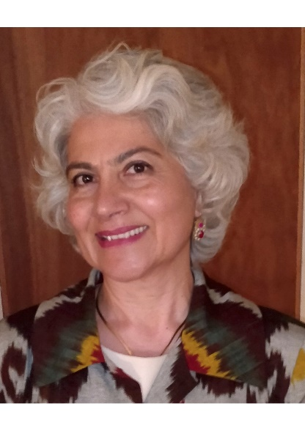
Dr. Gül Berna Özcan (http://tinyurl.com/gulbernaozcan)
is Reader in International Business and Entrepreneurship at Royal Holloway, University of London. Her research deals with internationalization of firms, business-politics relations, and entrepreneurs’ moral and religious engagement. Gül Berna is currently conducting research on Chinese firms operating in Central Asia. She is the author of several books and many research articles published in journals such as World Development, Journal of Business Research, Entrepreneurship and Regional Development and Environment and Planning C: Politics and Space. Her monograph, Building States and Markets: Enterprise Development in Central Asia (Palgrave, 2010), explores the characteristics of the emerging entrepreneurial middle class in Kazakhstan, Kyrgyzstan and Uzbekistan. Gül Berna edited a recent special issue of Central Asian Survey on post-Soviet development (2015, 34/4).

